PLC File Format

File extension doesn't matter. Each output line must end with a semicolon. Any text after the semicolon is ignored. All characters must be separated by spaces, including semicolons. The header should have each line end with the corresponding type (in, out, switch, crossing, in that order).

Input/Switch/Crossing Count

Header

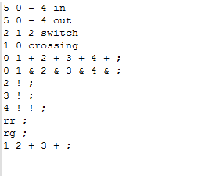File Header

First number in line is the number of items of each type. The next values represent the range of values in the full track for each output. Here, 0 – 4 means that the 5 inputs will come from the track blocks 0, 1, 2, 3, 4. Inputs and outputs don’t have to be the same amount or same block numbers. Switches are configured with switch count, and ID of each switch in the track. There can only be one crossing per PLC file, whose ID follows 1 if there is a crossing. WARNING: Changing the input or output blocks, switches, or crossings would require rewiring of the wayside controllers in a physical implementation.

Crossing

Outputs

Switches

Outputs

Each row represents each output from the header in order. In this example, the first 5 rows are the output for each of the output blocks, the next 2 rows are the switch outputs, and the last row is the crossing output. If the Boolean logic statement in the row is true, a zero authority signal will be sent to the track model and the stop lights will light up for the corresponding output block.

Inputs

The output is calculated from the block occupancies of the input blocks (true if occupied). The input block’s value can be accessed by selecting the local id of the input block (indexed by 0). In the above example, the track input values are 0 through 4, and the corresponding local input values will be 0 through 4 respectively.

Boolean Operations

The result for each row is calculated in postfix notation using the & + and ! operators (AND, OR, and NOT respectively). For Example, the line “1 2 & 3 + ! ; ” will result in prefix notation NOT(OR(AND(1, 2),3)) or in infix notation NOT((1 AND 2) OR 3).

Special Characters

The Special Characters, “v” and “g” represent true and false respectively (named after Vcc and GND). The characters “rr” and “rg” represent the routing information from the CTC. rr is “route red” and rg is “route green” these will be true if the next train approaching the switches to the yard should be routed into the yard.

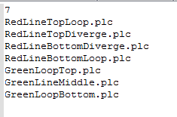

LineController Configuration

The line controller configuration is stored in a file called LineControllerConfig.txt. LineControllerConfig.txt should contain one filename for the configuration file.

The config file should contain the number of PLC files on the first line, followed by the name of each PLC file. This gives the default values in the LineController’s load window.

Track Configuration

The CTC and Track Model Use 2 separate files. The Track Model’s uses the file “TrackM.txt” and the CTC uses “track.txt” each of which contains block number, block type, connections, and other information about the block. These values can be modified, however, adding or removing a block will require reconfiguration of both files and the PLC files.